**Output (Screenshot)**

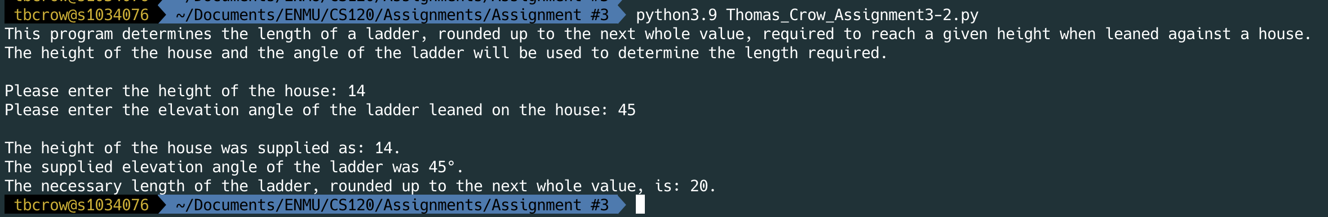

**Output (Copied and pasted)**

tbcrow@s1034076  ~/Documents/ENMU/CS120/Assignments/Assignment #3  python3.9 Thomas_Crow_Assignment3-2.py  ✔  119  17:32:45

This program determines the length of a ladder, rounded up to the next whole value, required to reach a given height when leaned against a house.

The height of the house and the angle of the ladder will be used to determine the length required.

Please enter the height of the house: 14

Please enter the elevation angle of the ladder leaned on the house: 45

The height of the house was supplied as: 14.

The supplied elevation angle of the ladder was 45°.

The necessary length of the ladder, rounded up to the next whole value, is: 20.

tbcrow@s1034076  ~/Documents/ENMU/CS120/Assignments/Assignment #3 